**API Integration Report**

**Schema Definition**

After schema definition, **‘category’** was added to categorize the products and later filter them based on their category as well.

**API Integration for Category-Based Listing**

**MockAPI** was used forthe data storing and mimicking of an actual API, this data was first transferred to the sanity studio like  
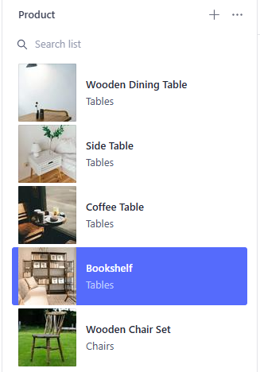  
  
Then was dsplayed on the frontend like  
**category based-filtration:**  
**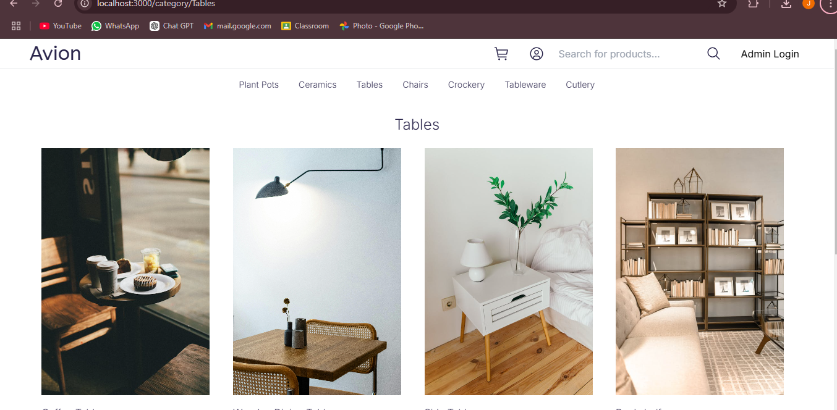  
  
In this way Day 3 came to an end.**